LLD Surf Poem #1

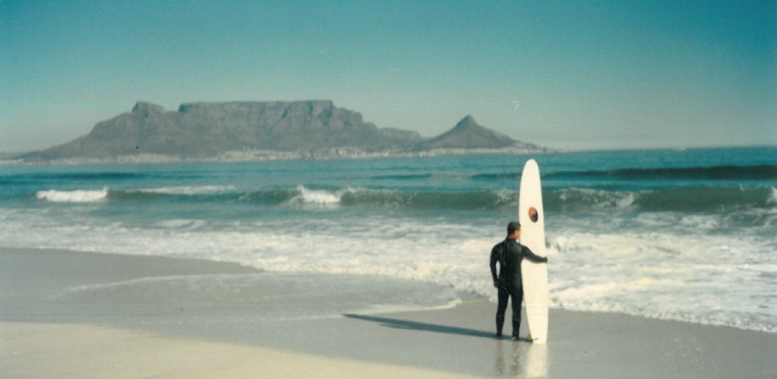
©1994 J Mahler
I stand

On a shoreline of the known-familiar
and gaze horizon way
to a flat-topped massif over the bay…

I am drawn
to ancient rock layed down by older ocean
whose rhythms in the primal waters of warm womb were also my beginnings…

I lust
that monument
for it’s elevation
for that summit’s sweet blue sky
where nothing’s between my stars and I

I taste
the iron blood
the sweat to shed
to rise
on every muscle shaking
with fibres I will yet be making
forward-up
inward-on…

I lick my lips
sun-streaked hair rippling with salty zephyrs trickling
hot-tickling my tanned back to take the step…

Do I go?
To go is to return, says the Tao
but as what, as who?

And yet, I want that unknown me to be
what this sea, this crossing, will make of me…

So let the casual sharks
between here
and there
beware!

For now I DO and now I DARE!

(Mahler, 3 Dec 2013)

