‘We are what suns and winds and waters make us…
We are the voice of our lands and our waters...’*

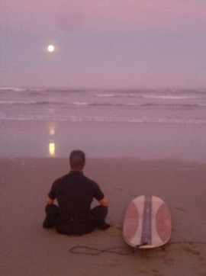
Full Moon Surf, Gonubie
© 2015 J Mahler

As a doctoral candidate under the Chair of the Law of the Sea and Development in Africa, I have found an intellectual home which resonates with my personal and professional ethos. My LLD topic is directly connected with the coastal and marine environment and also speaks to adventure/ extreme-sport tourism issues. I am exploring the sustainable management and regulation of coastal recreational activity through the lens of surfers/ surfing, as well as particular emerging phenomena associated therewith, such as ‘surf rage’. My wider research interests in this context extend to other forms of recreational and professional marine activity, scuba in particular, as well as the legal facilitation of scientific maritime exploration, underwater heritage (especially shipwrecks), aquaculture, alternative energy, coastal crimes and historical piracy, amongst others.
My personal connection with the coast and oceans is a lifelong ‘submergence’ inspired in part by the exploits of my grandfather (who, for example, walked around the Mediterranean in the 1920’s), my father (we built boats and kayaks together when I was younger), and my mother’s artistic spirit and love for all things including languages, cultures and the natural environment.
My other calling is pedagogy, especially legal pedagogy. I am particularly interested in ‘pirate pedagogy’ (a term I believe I coined in 2010), action research, activity, visuality, visual narrative and ‘audio-visual pivots’ (a term I coined in my LCP research work), as methods and tools (sometimes digitally mediated) for creating common frames of reference and entry points into legal discourse for demographically diverse students in developmental contexts. I plan to integrate my educational, literary and filmic interests with my doctoral work to produce audio-visual and literary artefacts arising from the spirit and themed around the substance of my research.
My LLD is in large part a quest to take my ocean passions to the next formal level, so that I can be of practical use in a trans-disciplinary manner, both in the field in relation to for example underwater archaeological digs, marine flora and fauna surveys, coastal community activism, environmental impact assessments, aquaculture and alternative energy projects, etc., but also in industry and academia, to be able to speak meaningfully with legal, entrepreneurial and scientific colleagues when investigating regulatory challenges to scientific endeavours, so as to make a modest yet meaningful contribution to solving some of the complex, pressing global concerns of our time.
I see my LLD work serving as a basis for additional future personal roles and writings, ideally as part of a trans-disciplinary team, project or regional/ global policy body in the marine or coastal context that ‘imagineers’ both scientific and social aspects of the sustainable use of maritime resources.

